**DAILY ONLINE ACTIVITIES SUMMARY**

|  |  |  |  |  |  |  |  |  |
| --- | --- | --- | --- | --- | --- | --- | --- | --- |
| **Date:** | **10-06-2020** | | | | | **Name:** | **Anix Jugal D’Cunha** | |
| **Sem & Sec** | **8 sem , A sec** | | | | | **USN:** | **4AL16CS013** | |
| **Online Test Summary** | | | | | | | | |
| **Subject** | | **--** | | | | | | |
| **Max. Marks** | | **--** | | **Score** | | | **--** | |
| **Certification Course Summary** | | | | | | | | |
| **Course** | **Master C# And SQL By Building Applications** | | | | | | | |
| **Certificate Provider** | | | **Udemy** | | **Duration** | | | 6 hours |
| **Coding Challenges** | | | | | | | | |
| **Problem Statement:** Python program takes a number and reverses it | | | | | | | | |
| **Status: Competed** | | | | | | | | |
| **Uploaded the report in Github** | | | | | **yes** | | | |
| **If yes Repository name** | | | | | **alvas-education-foundation/dcunhaanixjugal** | | | |
| **Uploaded the report in slack** | | | | | **yes** | | | |

Online Test Details: (Attach the snapshot and briefly write the report for the same)

Not Conducted

Certification Course Details: (Attach the snapshot and briefly write the report for the same)

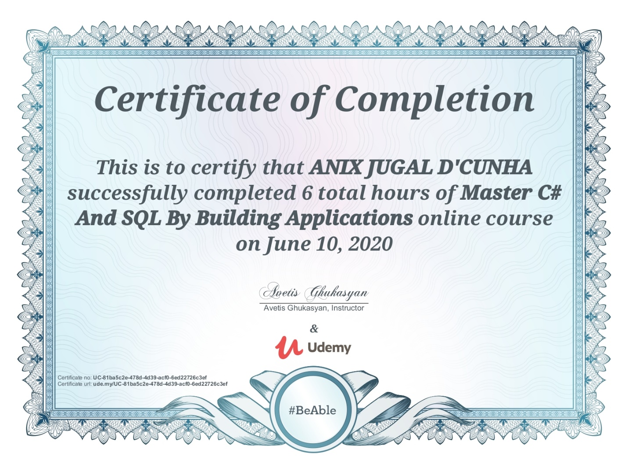

Coding Challenges Details: (Attach the snapshot and briefly write the report for the same)

Program-> Python program takes a number and reverses it

n=int(input("Enter number: "))

rev=0

while(n>0):

dig=n%10

rev=rev*10+dig

n=n//10

print("Reverse of the number:",rev)